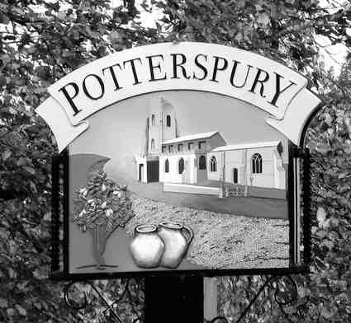
Potterspury Parish Council
Clerk: Mrs Jane Spence
clerk@potterspuryparishcouncil.gov.uk 07546 324266
www.potterspuryparishcouncil.gov.uk

CLERK & RESPONSIBLE FINANCIAL OFFICER
PERSON SPECIFICATION

Essential skills

- Strong financial management and record-keeping experience.
- Clear and confident communicator in both written and spoken English.
- Ability to work under own initiative, prioritise workloads and meet statutory deadlines.
- IT competency and experience using Microsoft 365, as well as website content management.
- Able to maintain good relationships with councillors, members of the public, contractors and other organisations.
- Research and report writing.

Desirable qualifications

- Experience of local government and public sector.
- A recognised qualification in local government administration, CiLCA, a degree or equivalent. (CILCA training will be offered to the successful candidate.)

Personal Attributes

- Conscientious, diligent, discrete, honest and reliable.
- Flexible approach to working – ability to attend evening meetings.
- Professional diplomatic and ability to be politically neutral.
- The Clerk’s home address will be the registered office of the Council and some space will be required for the storage of documents and files used regularly for working purposes. (Laptop, printer/scanner and filing cabinet provided).

For more details about the role of Parish Clerks download an introductory booklet from the
Society of Local Council Clerks (SLCC) entitled “The Essential Clerk”

